Lebanese American University
Department of Computer Science and Mathematics
CSC464 Deep Lear. & Nat. Lang Process

Enhancing Sentiment Analysis with Transformer Models:
A Comparison with Traditional Approaches

Rim Serhan, 202304818, rim.serhan@lau.edu
Mohamad Jawad Allouche, 202303973, mohammadjawad.allouche@lau.edu

A report submitted to Dr. Ahmad Audi in partial fulfillment of the requirements for the course
“CSC464: Deep Lear. & Nat. Lang Process” in Computer Science
Table of Contents
Introduction 4
Dataset 4
Figure 1: Sample of IMDB dataset showing text and corresponding labels 5
Preprocessing 5
Lowercasing 5
Tokenization 5
Stopwords 6
TF-IDF 6
Models 6
Baseline Model: Logistic Regression 6
Transformer Model: BERT 7
Training Process 7
Figure 2: Implementation of TF-IDF vectorization for feature extraction. 8
Evaluation Metrics 8
Accuracy 8
Precision 8
Recall 8
F1-score 8
Implementation Details 9
Results 9
Confusion Matrix Analysis 10
Figure 3: Confusion matrix illustrating model predictions 11
Discussion 11
Figure 4: Comparison of Logistic Regression and BERT models based 13
Conclusion 13

Introduction
Sentiment analysis is a fundamental task in Natural Language Processing (NLP) that focuses on understanding the emotional tone expressed in text. It is commonly used in real-life applications such as analyzing customer reviews, monitoring opinions on social media, and understanding user feedback on products or services. By automatically identifying whether a text is a positive or negative opinion, sentiment analysis helps organizations better understand user perspectives and make informed decisions.
Traditional approaches to sentiment analysis typically rely on machine learning models combined with feature extraction techniques such as Term Frequency–Inverse Document Frequency (TF-IDF). While these methods are relatively simple and efficient, they often fail to capture the full meaning of text because they treat words independently and do not fully consider context. As a result, their performance may be limited when dealing with complex or ambiguous text.
With the advancement of deep learning, more sophisticated models have been introduced to address these challenges. Transformer-based models, particularly Bidirectional Encoder Representations from Transformers (BERT), have significantly improved performance in NLP tasks. BERT processes text in a bidirectional manner, allowing it to better understand the context of words within a sentence. This allows the model to better capture semantic relationships between words and produce more accurate predictions.
The main objective of this project is to compare the performance of a traditional machine learning model, Logistic Regression, with a modern transformer-based model, BERT, for sentiment analysis. Both models are evaluated on the same dataset using consistent evaluation metrics. This comparison aims to highlight the strengths and limitations of each approach and highlight the advantages of modern NLP techniques over traditional methods.

Dataset
For this project, the IMDB movie reviews dataset was selected as the primary data source for sentiment analysis. This dataset is widely used in Natural Language Processing research and provides a reliable benchmark for evaluating classification models. It contains a large collection of movie reviews, each labeled as either positive or negative, making it suitable for binary sentiment classification tasks.
The dataset is divided equally into training and testing sets, with 25,000 reviews in each. One of the key advantages of this dataset is its balanced structure, as it contains an equal number of positive and negative samples. The balanced nature of the dataset ensures that the models are not biased toward a particular class, allowing for a fair evaluation of performance.
Due to computational limitations and to ensure that the project could be completed efficiently, a subset of the dataset was used. Specifically, a portion of both the training and testing data was selected while preserving the original balance between classes. This approach significantly reduces training time, especially for the transformer-based model, while still maintaining meaningful and representative results.
Each entry in the dataset consists of a textual movie review along with a corresponding label indicating its sentiment. The labels are binary, where 1 represents a positive sentiment and 0 represents a negative sentiment. This clear labeling structure simplifies the classification task and allows for straightforward evaluation of model performance.
Overall, the IMDB dataset provides a high-quality and well-organized collection of text data, making it an appropriate and effective choice for comparing traditional and modern approaches to sentiment analysis.
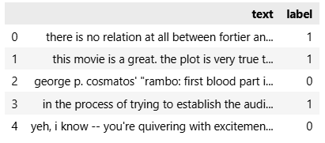
  - Figure 1: Sample of IMDB dataset showing text and corresponding labels

Preprocessing
Before training the models, several preprocessing steps were applied to prepare the text data for analysis. Preprocessing is an essential stage in any NLP task, as it helps improve data consistency and ensures that the models can effectively learn from the input.

Lowercasing
The first step involved converting all text to lowercase. This was done to normalize the data and reduce the size of the vocabulary. For example, words such as “Good” and “good” would otherwise be treated as different tokens. By converting all text to lowercase, the models can focus on learning meaningful patterns rather than differences in capitalization.

Tokenization
Another important step in text processing is tokenization, which refers to splitting text into smaller units called tokens. For the transformer-based model, tokenization was handled using the pre-trained tokenizer associated with the BERT model. This tokenizer is specifically designed to work with BERT and ensures that the input text is properly formatted for the model.

Stopwords
Stopword removal was also considered during preprocessing.
Stopwords are common words such as “the”, “is”, and “and” that are often removed in traditional text processing to reduce noise. However, in this project, stopwords were not removed for the BERT model. This decision was made because transformer-based models rely on the full context of a sentence, and removing such words could negatively affect the model’s ability to understand meaning and sentiment.

TF-IDF
For the baseline Logistic Regression model, a different approach was used. Since traditional machine learning models cannot process raw text directly, the data was transformed into numerical features using Term Frequency–Inverse Document Frequency (TF-IDF). This technique represents text based on the importance of words within a document relative to the entire dataset, allowing the model to identify relevant patterns for classification.
Overall, the preprocessing steps were kept simple but effective, ensuring that both models received appropriate input while maintaining a fair comparison between traditional and transformer-based approaches.

Models
This section describes the models used in this project and the overall training process. Two different approaches were implemented for sentiment classification: a traditional machine learning model (Logistic Regression) and a transformer-based model (BERT). The goal is to compare their performance under similar conditions.

Baseline Model: Logistic Regression
Logistic Regression was used as the baseline model for this project. It is a widely used algorithm for binary classification tasks due to its simplicity, efficiency, and strong performance on structured data. In the context of text classification, Logistic Regression is often combined with feature extraction techniques to convert textual data into numerical form.
Since machine learning models cannot process raw text directly, the input data was first transformed using TF-IDF vectorization. This method represents each document as a vector based on the importance of words relative to the dataset. Words that appear frequently in a specific document but less frequently across the dataset are given higher importance.
After vectorization, the Logistic Regression model was trained on the processed data to learn the relationship between word features and sentiment labels. This model serves as a reference point for evaluating the effectiveness of more advanced approaches.

Transformer Model: BERT
To improve performance and better capture contextual information, a transformer-based model was used. Specifically, the BERT (Bidirectional Encoder Representations from Transformers) model was selected due to its strong performance in various NLP tasks.
Unlike traditional models, BERT processes text in a bidirectional manner, meaning it considers both the left and right context of each word. This allows the model to better understand the meaning of words within a sentence and handle more complex language patterns.
In this project, a pre-trained BERT model was fine-tuned for sentiment classification. Fine-tuning involves taking an already trained model and adapting it to a specific task using labeled data. A classification layer was added on top of the model to predict whether a review is positive or negative.

Training Process
The training process for both models was designed to ensure a fair comparison. The same dataset split was used for both the baseline and BERT models, allowing their performance to be evaluated under consistent conditions.
For the Logistic Regression model, training involved fitting the model on TF-IDF features derived from the training data. This process is relatively fast and requires minimal computational resources.
For the BERT model, the training process involved tokenizing the input text, converting it into numerical representations, and updating the model weights based on classification loss. Due to computational limitations, the model was fine-tuned for one epoch using a subset of the dataset. Despite this limitation, the model was still able to achieve strong performance.
An LSTM model was also considered as a potential baseline due to its ability to capture sequential information in text. However, due to time and computational constraints, the comparison focused on Logistic Regression and BERT.
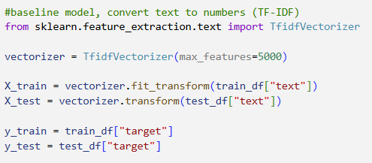
  - Figure 2: Implementation of TF-IDF vectorization for feature extraction.

Evaluation Metrics
To evaluate the performance of the models, several standard classification metrics were used. Relying on multiple metrics provides a more complete understanding of model performance, especially in classification tasks.

Accuracy
The primary metric used is accuracy, which measures the proportion of correctly classified samples out of the total number of predictions. While accuracy gives a general idea of performance, it does not always provide enough detail, especially when analyzing errors.
To gain deeper insight, additional metrics were used, including precision, recall, and F1-score.

Precision
Precision measures the proportion of correctly predicted positive instances out of all predicted positives. It reflects how reliable the model is when predicting a positive sentiment.

Recall
Recall, on the other hand, measures the proportion of actual positive instances that were correctly identified by the model, indicating how well the model captures relevant cases.

F1-score
The F1-score is the harmonic mean of precision and recall, providing a balanced measure that considers both false positives and false negatives. It is particularly useful when evaluating classification models, as it gives a more comprehensive view of performance compared to accuracy alone.
In addition to these numerical metrics, a confusion matrix was used to visualize the model’s predictions. The confusion matrix provides a breakdown of correct and incorrect classifications for each class, allowing for a clearer understanding of where the model makes errors.
Overall, the use of multiple evaluation metrics ensures a thorough and reliable assessment of model performance.

Implementation Details
The implementation of this project was carried out using Python in a Jupyter Notebook environment within Visual Studio Code. Several libraries were used to support data processing, model training, and evaluation.
The dataset was loaded using the datasets library, which provides easy access to the IMDB dataset. This allowed efficient handling of training and testing data without manual downloading or formatting. For preprocessing, basic text normalization such as lowercasing was applied, and the dataset was prepared in a format suitable for both traditional and transformer-based models.
For the baseline model, the scikit-learn library was used. The TfidfVectorizer was applied to convert text data into numerical feature vectors, which were then used to train a Logistic Regression classifier. Evaluation metrics such as accuracy and F1-score were also computed using built-in functions from the same library.
The transformer-based model was implemented using the transformers library. A pre-trained BERT model was loaded and fine-tuned for sentiment classification. The corresponding tokenizer was used to convert text into input IDs and attention masks required by the model. The training process was managed using the Trainer API, which simplifies model training and evaluation.
Due to computational limitations, the model was trained on a subset of the dataset for one epoch. Despite this constraint, the implementation was able to achieve strong performance, demonstrating the effectiveness of pre-trained models even with limited training.
Finally, evaluation was performed using both automated and manual approaches. In addition to built-in evaluation functions, custom code was used to compute accuracy, precision, recall, and F1-score, as well as to generate the confusion matrix for deeper analysis.

Results
This section presents the performance of both the baseline Logistic Regression model and the transformer-based BERT model on the sentiment classification task. The models were evaluated using the same dataset and metrics to ensure a fair comparison.
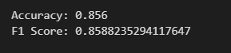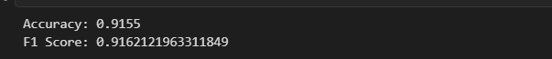
The Logistic Regression model, which uses TF-IDF features, achieved solid performance and serves as a strong baseline. However, the BERT model significantly outperformed the baseline, demonstrating the advantages of transformer-based approaches in capturing contextual information.
The results are summarized in the table below:
Model | Accuracy | F1 Score | Precision | Recall
Logistic Regression | 0.85 | 0.86 | - | -
BERT | 0.9155 | 0.9162 | 0.9086 | 0.924

As shown in the table, the BERT model achieved higher accuracy and F1-score compared to the Logistic Regression model. This indicates that BERT provides more reliable and consistent predictions across both classes.
The precision and recall values for the BERT model further confirm its strong performance. The high precision indicates that most predicted positive reviews are correct, while the high recall shows that the model successfully identifies a large proportion of actual positive reviews. The balanced F1-score reflects the model’s ability to maintain both precision and recall effectively.
Overall, the results demonstrate that the transformer-based model is more effective for sentiment analysis compared to the traditional baseline approach.

Confusion Matrix Analysis
To further analyze the performance of the BERT model, a confusion matrix was used to visualize the classification results. The confusion matrix provides a detailed breakdown of correct and incorrect predictions for both positive and negative classes.
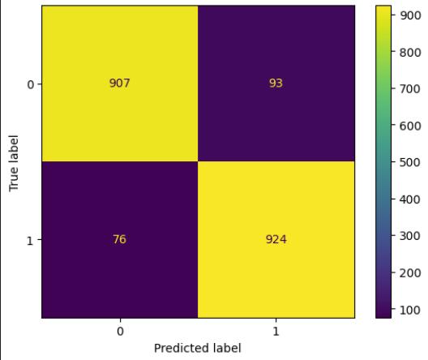
  - Figure 3: Confusion matrix illustrating model predictions

The results show that the model correctly classifies the majority of both positive and negative reviews, with a high number of true positives and true negatives. This confirms that the model is able to distinguish effectively between the two sentiment classes.
However, a small number of misclassifications are observed. Some positive reviews are incorrectly predicted as negative, and vice versa. These errors may occur in cases where the text contains ambiguous language, sarcasm, or mixed sentiments, making it more difficult for the model to interpret the overall meaning.
Despite these minor errors, the number of incorrect predictions remains relatively low compared to the total number of samples. This indicates that the model performs consistently well across both classes.
Overall, the confusion matrix provides valuable insight into the model’s behavior, showing not only its high accuracy but also how prediction errors are distributed. This helps confirm the reliability and robustness of the BERT model for sentiment classification.

Discussion
The results obtained from this study clearly demonstrate the performance gap between traditional machine learning approaches and modern transformer-based models in sentiment analysis tasks. While the Logistic Regression model achieved reasonable performance, the BERT model consistently outperformed it across all evaluation metrics, including accuracy, F1-score, precision, and recall.
One of the main reasons for this difference lies in how each model processes text. Logistic Regression relies on TF-IDF representations, which treat text as a collection of independent words without considering their order or contextual relationships. Although TF-IDF is effective in capturing word importance, it lacks the ability to understand meaning beyond individual tokens. As a result, the model may struggle with sentences where context plays a crucial role in determining sentiment, such as those containing negation, sarcasm, or subtle emotional cues.
In contrast, the BERT model is specifically designed to capture contextual information through its bidirectional architecture. By analyzing both the left and right context of each word, BERT is able to build a deeper understanding of sentence structure and meaning. This allows it to handle more complex linguistic patterns and produce more accurate predictions. The improved performance observed in this project confirms the effectiveness of contextual embeddings in natural language understanding tasks.
Another important observation is the balance between precision and recall in the BERT model. The relatively high values for both metrics indicate that the model is not only accurate but also consistent in identifying both positive and negative samples. This balance is particularly important in sentiment analysis, where misclassifications can impact the interpretation of user opinions.
It is also worth noting that, despite its strong performance, the BERT model comes with higher computational costs compared to the baseline model. The training process required significantly more time and resources, highlighting a key trade-off between model complexity and efficiency. In practical applications, this trade-off must be carefully considered depending on the available resources and the required level of performance.
Additionally, while an LSTM model was initially considered due to its ability to capture sequential dependencies in text, it was not implemented in this project due to time constraints. However, LSTM-based approaches generally fall between traditional models and transformer-based models in terms of performance, as they can capture sequence information but lack the full contextual understanding provided by transformers.
Finally, the use of a subset of the dataset may have slightly limited the model’s ability to generalize. Although the results remain strong, training on the full dataset could potentially lead to further improvements in performance. Future work could explore training on larger datasets, experimenting with additional models, or fine-tuning hyperparameters to achieve even better results.
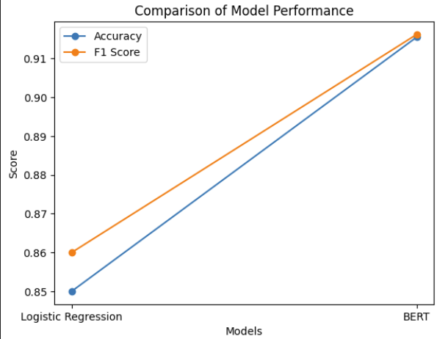
  - Figure 4: Comparison of Logistic Regression and BERT models based
  - on accuracy and F1-score.

As shown in Figure 4, the BERT model outperforms Logistic Regression in both accuracy and F1-score, highlighting the effectiveness of transformer-based models in capturing contextual information.
Overall, this project highlights the clear advantages of transformer-based models in sentiment analysis while also emphasizing the importance of considering computational efficiency and practical constraints.

Conclusion
In this project, sentiment analysis was performed using both a traditional machine learning approach and a modern transformer-based model. The primary objective was to compare the performance of Logistic Regression and BERT on the same dataset and evaluate their effectiveness in classifying movie reviews as positive or negative.
The results clearly show that the BERT model outperforms the baseline Logistic Regression model across all evaluation metrics. By leveraging contextual understanding through its bidirectional architecture, BERT is able to capture the meaning of text more effectively than traditional methods that rely on fixed feature representations such as TF-IDF. This leads to more accurate and reliable predictions, particularly in cases where sentiment depends on context.
At the same time, the project also highlights the trade-off between performance and computational cost. While Logistic Regression is simple, fast, and efficient, its performance is limited compared to more advanced models. On the other hand, BERT achieves significantly better results but requires more computational resources and longer training time. This trade-off is an important consideration when selecting models for real-world applications.
Overall, this study demonstrates the importance of contextual modeling in natural language processing and confirms that transformer-based models provide substantial improvements over traditional approaches. The findings of this project align with recent advancements in NLP and reinforce the effectiveness of modern deep learning techniques for text classification tasks.

